**Duncan, Isadora (b. 26 May 1877, San Francisco, CA; d. 14 September 1927, Nice, France)**

**Summary**

Frequently credited with the invention of modern dance, Isadora Duncan was a choreographer, dancer, educator, international star, and author of a bestselling autobiography *My Life* (1927). Her choreography drew most prominently from popular social dance genres, the poses and gestures depicted in classical art, and exercises promoted by the twentieth-century physical culture movement. Her hybrid performance form combined these popular and ancient influences with expressive solo dance, live orchestral music, non-naturalistic stage décor, and inflammatory curtain-call speeches resembling modernist manifestos. In the first decades of the twentieth century, numerous artists and spectators heralded Duncan as a muse of modernism. Yet for some contemporaries and later commentators, her understanding of dance as the expression of the soul made her seem nostalgic and anti-modern. In fact, her incongruent combination of metaphysical and materialist discourses, along with her contradictory claims of a desire for popularity and hostility toward popular audiences, highlight common tensions in modernism. Duncan’s performances and her written and embodied manifestos influenced many spheres of twentieth-century art and culture, including Italian Futurism, the Moscow Art Theatre, Greenwich Village Radicalism, and the women’s movement.

**Training**

Duncan celebrated her lack of formal ballet training with an anecdote about leaving her third lesson after declaring that dancing en pointe was unnatural and ugly. Duncan’s mother was a music teacher who taught her children popular social dances, which encouraged Duncan’s later use of waltz and polka steps. Duncan also studied American Delsartism, the popular movement derived from the theories of French performer and teacher*,* François Delsarte. Delsartism’s main interest for Duncan was its emphasis on linking emotion and gesture and its promise that bodily movement both expressed and constructed a unique and sacred self. The influence of Delsartean ideas about the relations between body, spirit, and gesture is evident throughout Duncan’s published aesthetic statements, but her 1898 essay, ‘Emotional Expression’, from *The Director,* explicitly praised Delsarte as ‘the master of all principles of flexibility and lightness of body’ (109). When, in the 1890s, Duncan began teaching to supplement the family income, she advertised herself as a ‘Professor of Delsarte’. She later repudiated Delsartism, as she did ballet, to assert her originality.

Instead of ballet or physical culture, Duncan claims to have learned natural and classical dance by studying ancient Greek art in the British Museum. She travelled to London by livestock ship in 1899 to begin her career abroad after dissatisfying performances in Chicago,New York, and Rhode Island. Among the collections she studied at the British Museum were the celebrated fourth-century B.C.E. terra cotta figurines unearthed at Tanagra, Greece in 1873. The statuettes of women dancing or participating in funerary rites inspired Duncan’s early piece, *Tanagra Figures* (date unknown), which is among the most widely known from the Duncan repertory today. The choreography is a series of poses that mimic the *S*-curve in Greek sculptures of the body and the open, two-dimensional quality of figures in ancient frescoes.

Duncan continued studying statuary after 1900 at the Louvre in Paris, where she met the sculptor Auguste Rodin, who befriended and sketched Duncan. She incorporated gestures from Rodin’s *Gates of* *Hell* (begun in 1880) into her *Furies* (1911). Unlike the sequenced posing of *Tanagra* *Figures*, *Furies* quickly strikes tortured postures from the sculpture and invents movement for its still figures. Belying caricatures of her dance as monolithically nymph-like, *Furies* explores weightedness, bodily contortions, floorwork, and falls—movement innovations that dance history has often attributed to later figures.

Duncan vocally rejected the other dance forms of her period even as she borrowed from their techniques. She claimed that ballet’s rigid spine was puppet-like and unnatural; she argued that originality is undermined by any movement system, including Delsartism; she criticized the skirt dancers, chorus girls, and Salomé dancers for their false, erotic displays; she argued against any apparatus that concealed or embellished the body. Duncan’s autobiography claims that her only dance masters were famous philosophers and writers including the poet Walt Whitman, who celebrated a unique American self, the German evolutionary scientist Ernst Haeckel, who advanced a monistic theory of body and spirit, and the German philosopher Friedrich Nietzsche, who frequently referenced dance as an image of life-affirmation. These figures were all famous during Duncan’s time, but she was innovative in that she translated their ideas into choreography and dance technique.

**Major contributions to the Field and to Modernism**

When Duncan returned to tour the U.S. in 1908, she was already an international star. Modern dance was, then, an early transnational movement that influenced many different trajectories of modernism. Her choreography of mythic and primitive themes encouraged modern dance’s explorations of foreign dance forms, as evident in Ruth St. Denis’s *Radha* (1906) or Ted Shawn’s *Japanese Spear Dance* (1919). Duncan’s insistence that every gesture must express an emotion became a central tenant of modern dance. Her choreography of walks, skips, and runs anticipated the pedestrian choreography of the Judson Dance Theater group and other founders of postmodern dance. In addition to pieces that explored traditional feminine roles, like *Mother* (1924), she celebrated female strength and violence in *The Amazons* (1906) and *Marseillaise* (1915). These works influenced futurist dancers including Giannina Censi (1913–1995) and Valentine de Saint-Point (1875–1953), who also celebrated the warrior-spirit but added a machine aesthetic less present in Duncan’s dance. Futurist organizer F. T. Marinetti praised Duncan’s interpretation of ‘free dance’ but not what he called her ‘childishly feminine’ representation in his 1917 ‘Manifesto of the Futurist Dance’ (137).

Duncan’s movement innovations also reinvigorated ballet, having a particularly generative impact on the Russian ballet during her 1904, 1905, and 1908 tours. Her audiences included the impresario Serge Diaghilev and choreographer Michel Fokine, who would soon transform dance with the founding of Diaghilev’s Ballets Russes in 1909. Duncan’s parallel positions rather than turned out feet and emphasis on the weight of the body rather than gravity-defying leaps and point-work influenced the primitivist style of Fokine’s *Petrushka* (1911)and Vaslav Nijinsky’s *Le Sacre du Printemps* (1913). Both were impressed by Duncan’s ability to create the illusion of spontaneous dance through strategies like lagging slightly behind the beat as if the music propelled her to movement. Similarly, Duncan technique requires that dancers convey a desire to move by changing focus or expression before executing the gesture to suggest an instantaneous impulse. Duncan’s ability to simulate spontaneity also influenced the Russian director and acting theorist Konstantin Stanislavsky, whose autobiography describes watching her dance in 1905 and his hopes to achieve similar effects through rehearsed spontaneity in his acting technique.

Modernist writers flocked to Duncan’s performances, and she appears in John Dos Passos’s novel *The Big Money* (1936), an unfinished biography by Mina Loy, and poems by William Carlos Williams, Carl Sandburg, and Sylvia Plath, to name a few. Duncan’s danced adaptations of myths encouraged reinterpretations and translations of classical texts, including H.D.’s *Hippolytus Temporizes* (1927)and *Ion* (1937) and Ezra Pound’s *Elektra* (1949) and *Women of Trachis* (1954). All adopt creative strategies T. S. Eliot famously described as the modernist mythical method in a review of James Joyce’s *Ulysses* (1922), perhaps the most famous adaptation of classical myth in the period.

Artists also hoped to depict the energy of Duncan’s dance on paper and in sculpture. She was the subject of sketches and paintings by Gordon Craig, Abraham Walkowitz, and José Clara, among others. She inspired Emile-Antoine Bourdelle’s designs for the façade of the Theatre des Champs-Elysees. Her 1915 American tour introduced her to New York’s young intellectuals, artists and revolutionaries based in Greenwich Village including Floyd Dell, Max Eastman, and John Sloan. As editors of *The Masses*, a radical publication, they helped establish the image of the new woman of modernismin drawings and articles supporting equality and suffrage. Duncan’s expressive body, dancing alone onstage, became the prototype for this image of the modern woman and a symbol of avant-garde artistic and social liberation. The May 1915 edition of *The Masses* features a cover designed by Sloan illustrating the preparation for a leg extension in Duncan’s *Marche Militaire* (c. 1909).

**Legacy**

Duncan’s legacy has frequently been overshadowed by her biography, sensationalized in films (Ken Russell’s 1996 *The Biggest Dancer in the World*), books (Sewell Stokes’s 1928 *Isadora: An Intimate Portrait*), and plays (Martin Sherman’s 1991 *When She Danced*). Her life was undeniably tumultuous and controversial: the deaths of her daughter and son in April 1913 when their car plunged into the Seine, her marriage to the Russian poet Sergei Esenin, who later committed suicide, the loss of her U.S. citizenship following accusations of communist sympathies, and her strangulation in 1927, when her long scarf caught in the wheel of a convertible. Some critics have suggested that Duncan’s dance died with her because her performances were improvisational. Duncan encouraged such myths with her illusion of spontaneity and insistence that dance expressed the performer’s own soul.

Duncan was actually a careful choreographer and educator, and she founded three schools to teach her dances, technique, and aesthetic ideas. The Grünewald School, established in 1904 in Germany, produced her six most famous students, Anna, Maria-Theresa, Irma, Lisa, Gretel, and Erika Duncan, who took her last name and toured together as the *Isadorables*. The school she opened at Bellevue near Paris in 1914 closed with the outbreak of the Second World War. Duncan founded another school in Moscow in 1921 but left it largely to Irma after her marriage to Esenin in 1922.

Several of Duncan’s students continued to perform together and as soloists and to teach Duncan’s choreography and technique around the world. Their students, and students of their students in turn, have kept the practice of Duncan dancing alive. Maria-Theresa Duncan founded the Isadora Duncan International Institute (IDII) in New York in 1977 to preserve Duncan’s choreography and technique. The Isadora Duncan Dance Foundation, established by Lori Belilove in 1979, also teaches classes and seminars, and its resident company continues to perform Duncan’s choreography.

**Carrie Preston**

**Selected Works**

*Narcissus* (1900)

*Water Study* (c. 1900)

*Blue Danube* (1902)

*Rakoczy March* (1902)

*Beethoven’s Symphony no. 7* (1904)

*Iphigénie* (1904)

*Bahlspiel* (c. 1905)

*Lullaby* (1905)

*The Suppliants* (1904)

*The Amazons* (1906)

*Moment Musicale* (1908)

*Marche Militaire* (1909?)

*Bacchanale* and other excerpts from *Tannhäuser* (1911)

*Furies* (1911)

*Orphée* (1911)

*Ave Marie* (1914)

*Rédemption* (1914)

*Marseillaise* (1915)

*Oedipus Rex* (1915)

*Pathétique* (1916)

*The Three Graces* (1917)

*Funérailles* (1918)

*Mother* (1924)

*Revolutionary* (1924)

**Artist’s Writings**

Duncan, I. (1928) *The Art of the Dance*, ed. S. Cheney, New York: Theater Arts.

--- (1898) ‘Emotional Expression’, *The Director* 1 (4): 109-111.

[The entirety of the short-lived magazine *The Director: Dancing, Deportment, Etiquette, Aesthetics, Physical Training* (1897-98) has been reprinted by Dance Horizons.]

--- (1927) *My Life,* New York: Boni and Liveright.

**References and Further Reading**

Daly, A. (1995) *Done into Dance: Isadora Duncan in America*, Bloomington: Indiana University Press.

Duncan, I. (1970) *The Technique of Isadora Duncan*, New York: Dance Horizons.

Jowitt, D. (1989) “In Search of Motion,” in *Time and the Dancing Image*, Los Angeles: University of California Press, 67-102.

Kurth, P. (2001) *Isadora: A Sensational Life*, New York: Little Brown.

LaMothe, K. (2006) *Nietzsche’s Dancers: Isadora Duncan, Martha Graham, and the Revaluation of Christian Values*,New York: Palgrave.

Marinetti, F. T. (1917) ‘Manifesto of the Futurist Dance’, in *Marinetti: Selected Writings*, eds. R. W. Flint and A. Coppotelli (1972), New York: Farrar, Straus and Giroux.

Preston, C. (2011) *Modernism’s Mythic Pose: Gender, Genre, Solo Performance*, New York: Oxford University Press.

Stanislavsky, K. (1924) *My Life in Art*, trans. J. J. Robbins, New York: Theatre

Arts.

**Film documentaries**

Gamson. A. (1988) *On Dancing Isadora’s Dances*, New York: Dance Solos.

Goldfine, D. and D. Geller (1989) *Isadora Duncan—Movement from the Soul*, Los Angeles: Direct Cinema Ltd.

Levien, J. (1988) *The legacy of the choreography of Isadora Duncan*, New York: Dance Films Association.

Mantell-Seidel, A. and J. Levien (1995) *Isadora Duncan: Technique and Repertory*, Princeton: Dance Horizons Video.

**Digital resources**

Duncan, A, (August 1942), “Anna Duncan, Recorded at Jacob’s Pillow,” *Jacob’s Pillow Dance Interactive*: [http://danceinteractive.jacobspillow.org/dance/anna-duncan?ref=artist&refcar=/artist/c-d.](http://danceinteractive.jacobspillow.org/dance/anna-duncan?ref=artist&refcar=/artist/c-d.%20) (A recording of Anna Duncan dancing at Jacob’s Pillow in 1942; the choreography is unidentified but may be a variation on Duncan’s early *Prelude*.)

Isadora Duncan Dance Foundation: <http://www.isadoraduncan.org/> (Homepage of Lori Belilove & The Isadora Duncan Dance Company, the preeminent group performing and teaching Duncan choreography and technique. The site offers information about classes, intensive workshops, and company performances.)

Isadora Duncan International Institute (IDII): <http://www.isadoraduncan.net/> (IDII was founded in New York in 1977 by Maria-Theresa Duncan, one of Duncan’s adopted daughters, and Kay Bardsley. Under the artistic direction of Jeanne Bresciani, IDII continues to teach Duncan’s choreography and dance technique and offers certificate programs.)

Gold, S. (1984) *A Selection of Isadora Duncan Dances* accessible online at <http://www.dancewriting.org/acrobat/duncan/Isadora_Duncan_Dances.pdf>

**Paratexts in accompanying file named REM.Duncan.images**

Fig. 1. Isadora Duncan, by Paul Berger (1908). Irma Duncan Collection. Courtesy of the

Jerome Robbins Dance Division, The New York Public Library for the Performing Arts,

Astor, Lenox and Tilden Foundations.

Fig. 2. Isadora Duncan in *Marseillaise* by Arnold Genthe (1915–1918). Courtesy of the Jerome Robbins Dance Division, The New York Public Library for the Performing Arts, Astor, Lenox, and Tilden Foundations.

Fig. 3. ‘Isadora Duncan in the *Marche Militaire*’ by John Sloan. From the *Masses* (May 1915). © 2010 Delaware Art Museum/Artists Rights Society (ARS), New York. Photo courtesy of the Library of Congress.

**Figures**

Fig. 1. Isadora Duncan, by Paul Berger (1908). Irma Duncan Collection. Courtesy of the

Jerome Robbins Dance Division, The New York Public Library for the Performing Arts,

Astor, Lenox and Tilden Foundations.

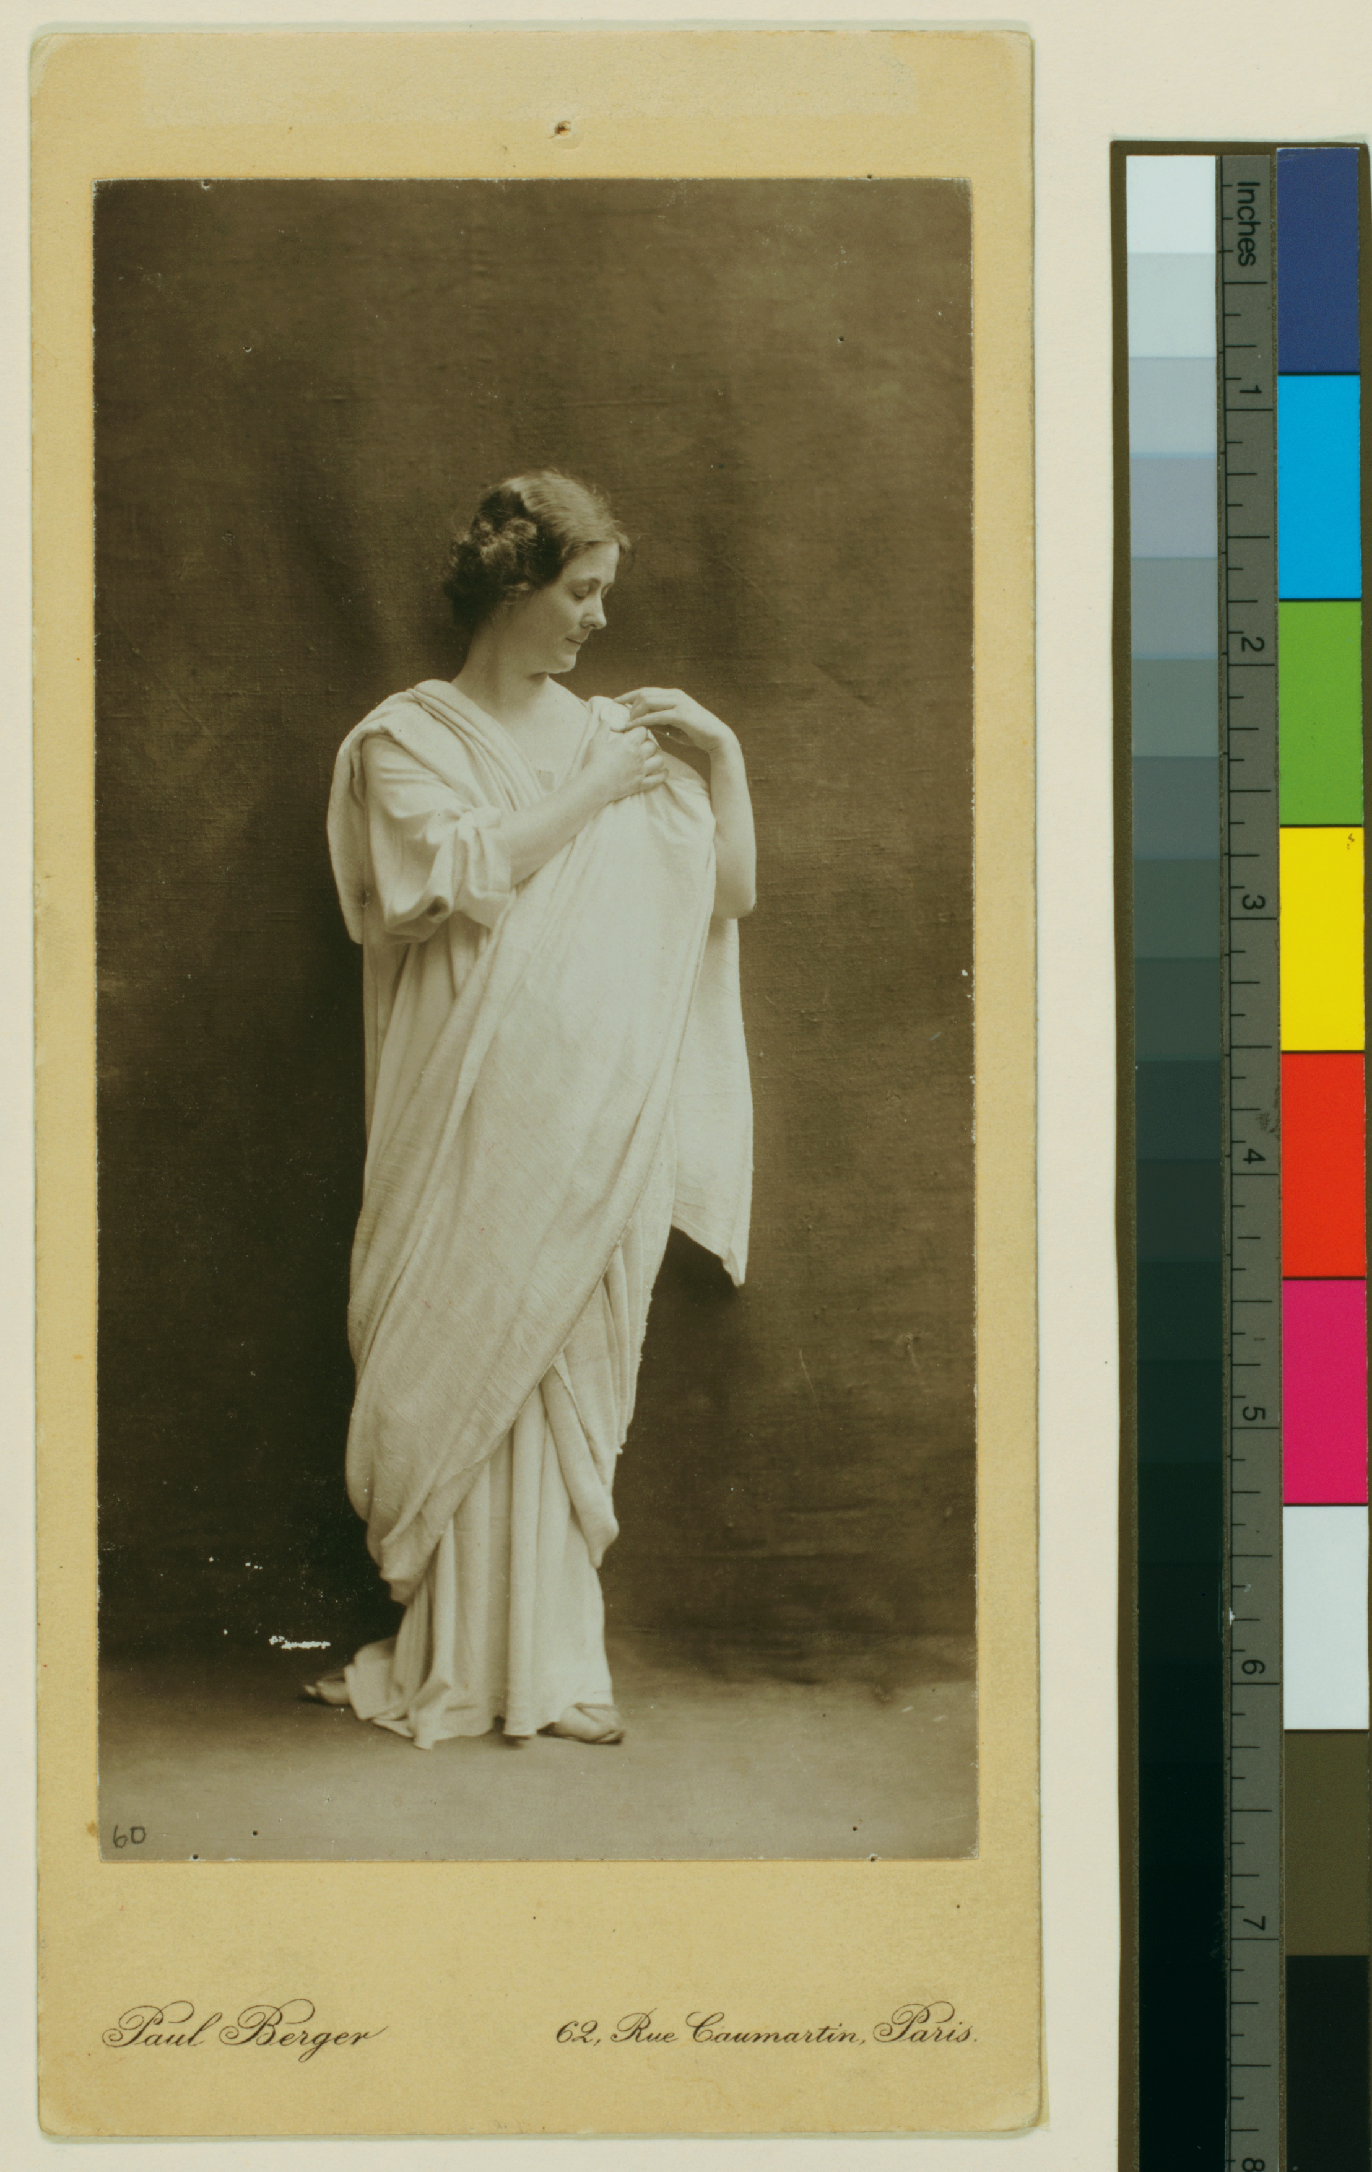

Fig. 2. Isadora Duncan in *Marseillaise* by Arnold Genthe (1915–1918). Courtesy of the Jerome Robbins Dance Division, The New York Public Library for the Performing Arts, Astor, Lenox, and Tilden Foundations.

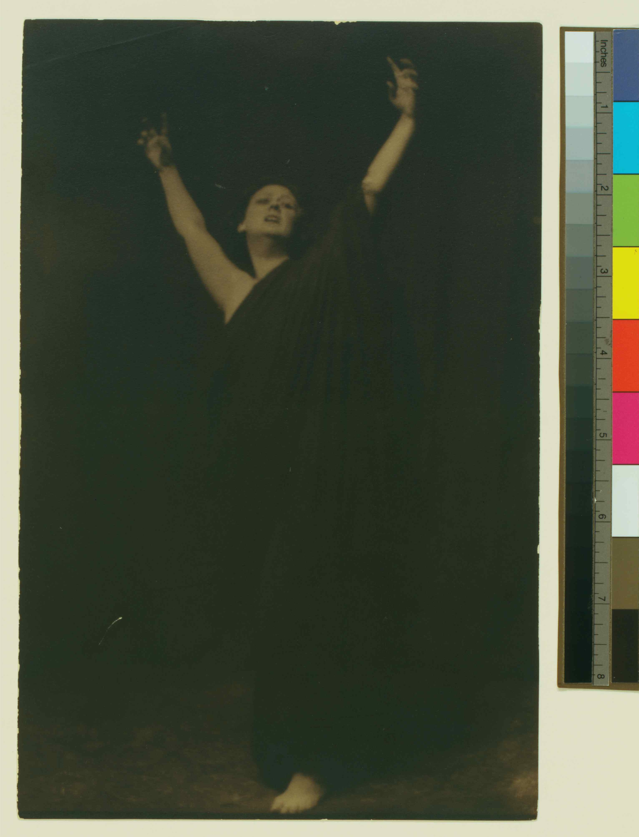

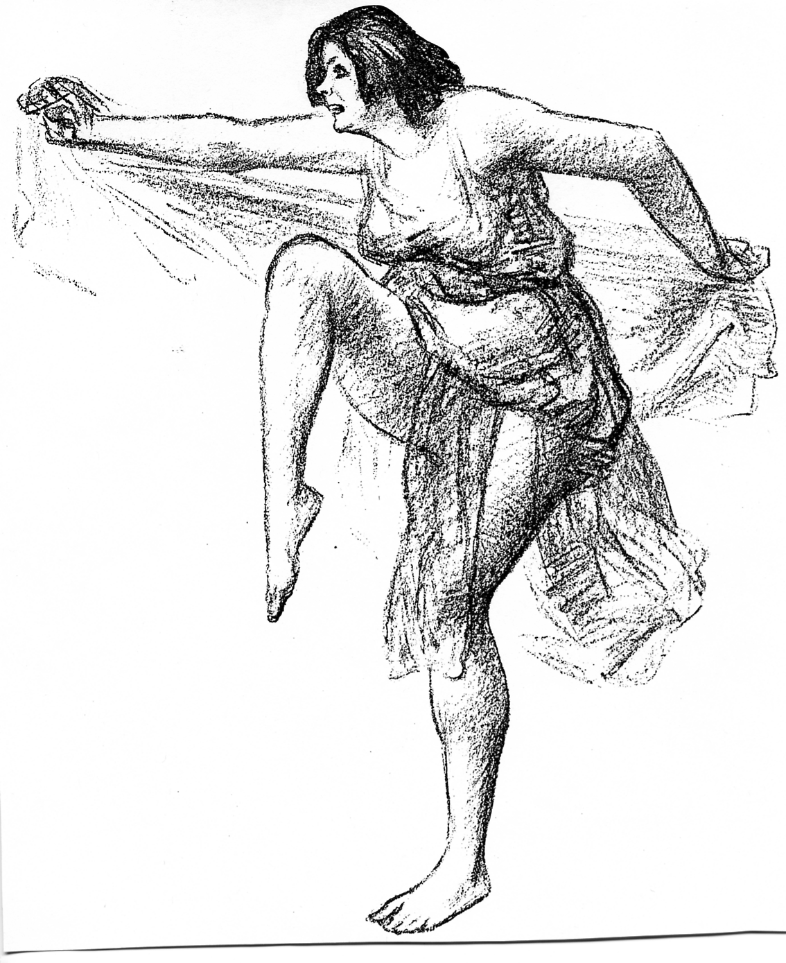Fig 3. “Isadora Duncan in the *Marche Militaire*” by John Sloan. From the *Masses* (May 1915). © 2010 Delaware Art Museum/Artists Rights Society (ARS), New York. Photo courtesy of the Library of Congress.